**PSFML Sessions 3&4 Homework**

**Full Name: ____________________________**

**Group No.: __**

**Lecturer Name: ________________**

**Submission date: _/_/__ Grade: __/40**

## Please write down all the steps not the final answer only

## Questions (40 points):

1. (5 points) Let X be a discrete random variable with the following PMF

|  |  |  |  |  |  |  |
| --- | --- | --- | --- | --- | --- | --- |
| X | 0.2 | 0.4 | 0.5 | 0.8 | 1 | Otherwise |
| P(X) | 0.1 | 0.2 | 0.2 | 0.3 | 0.2 | 0 |

1. Write the random variable space of X
2. Find P(X<= 0.5)
3. Find P(0.25<X<0.75)
4. Find P(X=0.2|X<0.6)
5. (5 points) Let X be a discrete random variable with the following PMF

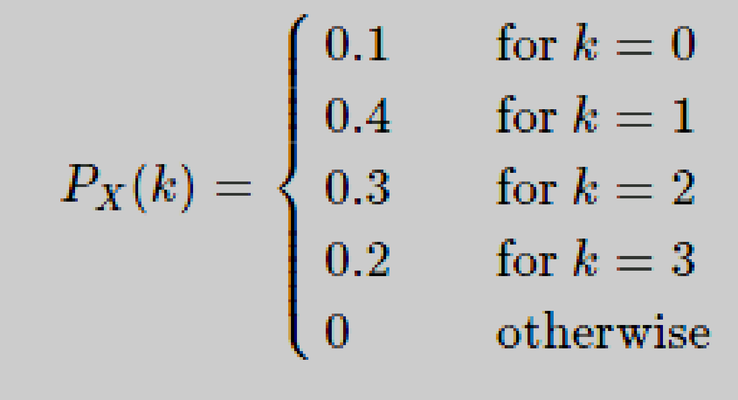

1. Find E[X].
2. Find Var(X).
3. If Y=(X−2)2, find E[Y].
4. (3 points) Let X and Y be two independent random variables. Suppose that we know Var(2X−Y)=6 and Var(X+2Y)=9. Find Var(X) and Var(Y).
5. (5 points) You take an exam that contains 20 multiple-choice questions. Each with four choices. You know the answer to 10 questions, and you choose random answers to the other 10 questions. Your score X on the exam is the total number of correct answers. Find the PMF of X. What is P(X>15)?
6. (3 points) The number of customers arriving at a grocery store is a Poisson random variable. On average 10 customers arrive per hour. Let X be the number of customers arriving from 10am to 11:30am. What is P(10 < X ≤ 15)?

(hint: look up the Probability mass function of Poisson distribution)

1. (5 points) Suppose that the time between emergency calls to a fire station follows an exponential distribution with an average rate of 1.8 calls per day.
2. A fireman has just arrived. What is the chance of a call in the next 15 minutes?
3. A fireman has finished his shift 15 minutes to go with no call during his shift. What is the chance of a call will happen in the next 15 minutes?

(hint: look up the exponential distribution probability distribution function or the cumulative distribution function. You may use either of them)

1. (3 points) Suppose that crowd size at home games for a particular football club follows a Normal distribution with mean 26 000 and standard deviation 5000. What percentage of crowds are between 31 000 and 36 000? (Hint: F(1)= 0.8413 and F(2) = 0.9772)
2. (4 points) Suppose we send 30% of our products to company A and 70% of our products to company B. Company A reports that 5% of our products are defective and company B reports that 4% of our products are defective.
3. Find the probability that a product is sent to company A and it is defective.
4. Find the probability that a product is sent to company B and it is not defective.
5. (4 points) One box has 7 red balls and 3 white balls; a second box has 6 red balls and 4 white balls. A pair of dice are tossed. If the sum of the dice are less than five, a ball is selected from the first box, otherwise the ball is selected from the second box. Find the probability of getting a red ball.
6. (3 points) A basketball team is to play two games in a tournament. The probability of winning the first game is 10%. If the first game is won, the probability of winning the second game is 15%. If the first game is lost, the probability of winning the second game is 25%. What is the probability the first game was won if the second game is lost?

## Practice with code (Ungraded but MUST DO BEFORE THE PRACTICAL SESSION):

1. Open and run Distributions.ipynb
2. For each distribution compute the expected value, var, std and create another random variable from different distribution and compute the correlation and covariance.
3. Re-code all the coding using scipy.stats instead of numpy using [binom, poisson, norm, expon, uniform(), pmf(), cdf(), mean(), var(), std(), rvs()]

## Readings:

* Discrete Probability Distributions (with solved examples): <https://learn.lboro.ac.uk/archive/olmp/olmp_resources/pages/workbooks_1_50_jan2008/Workbook37/37_1_dscrt_prob_distn.pdf>
* PMF and PDF: <https://towardsdatascience.com/probability-concepts-explained-probability-distributions-introduction-part-3-4a5db81858dc>
* Joint, marginal and conditional probability: <https://towardsdatascience.com/deep-learning-book-series-3-4-and-3-5-marginal-and-conditional-probability-8c6239e453b8>
* Bayes rule: <https://www.mathsisfun.com/data/bayes-theorem.html>
* Naïve Bayes Classifier with examples: <https://web.iitd.ac.in/~bspanda/BY.pdf>
* Naïve Bayes Classifier with python implementation: <https://www.analyticsvidhya.com/blog/2021/01/a-guide-to-the-naive-bayes-algorithm/>
* Maximum likelihood: <https://www.mygreatlearning.com/blog/maximum-likelihood-estimation/>
* List of all Probability distributions <https://www.statisticshowto.com/probability-distribution/>